Water Resources Research
Supporting Information for
Distributed Hydrological Modeling with Physics-Encoded Deep Learning: A General Framework and Its Application in the Amazon
Chao Wang¹, Shijie Jiang^{2,3,4}, Yi Zheng^{1,5,6}, Feng Han^{1,5}, Rohini Kumar⁴, Oldrich Rakovec⁴, Siqi Li¹
¹School of Environmental Science and Engineering, Southern University of Science and Technology, Shenzhen, China.
²Department of Biogeochemical Integration, Max Planck Institute for Biogeochemistry, Jena, Germany.
³ELLIS Unit Jena, Jena, Germany
⁴Department of Computational Hydrosystems, Helmholtz Centre for Environmental Research – UFZ, Leipzig, Germany.
⁵Shenzhen Municipal Engineering Lab of Environmental IoT Technologies, Southern University of Science and Technology, Shenzhen, China.
⁶State Environmental Protection Key Laboratory of Integrated Surface Water‐Groundwater Pollution Control, Southern University of Science and Technology, Shenzhen, China

Contents of this file
Texts S1 to S4
Figures S1 to S11
Tables S1 to S7
Introduction
The supporting information covers the encoding framework of the physical neural network (NN), details on the routing process, experiments using different deep NN structures within the replacement NN, experiments with different weighting schemes, results of spatiotemporal splitting, hyperparameters of the NNs and the training process, smooth approximation methods, model performances for various statistical indicators, time series of 24 hydrological stations, a description of the parameter $f_{crit}$, the river routing network with manual modification, information on static attributes and dynamic forcings in the Amazon Basin, information on the modeling uncertainty, comparisons of the results of HydroPyNN and HydroPy, and information on the nine Amazon sub-basins.

Text S1. Encoding framework for physical processes in the distributed hybrid model
The physical core of the hybrid model is the physical NN, which encodes the hydrological system equations into the RNN architecture. A hydrological system is often characterized by a state-space representation, which describes the system response to certain inputs and can be modeled by a combination of state equations and output equations in the following form:
$$\begin{aligned}\left\{\begin{aligned}\frac{d}{dt}s\left(t\right)=f\left(s\left(t\right),x\left(t\right);θ^{〈f〉}\right) \\ y\left(t\right)=g\left(s\left(t\right),x\left(t\right);θ^{〈g〉}\right)\end{aligned}\right.\#\left(S1\right)\end{aligned}$$
where $s\left(t\right)$, $x\left(t\right)$, and $y\left(t\right)$ denote the state vectors, input vectors, and output vectors with respect to time $t$, respectively; $f$ and $g$ are the system dynamics and responses, respectively; and $θ^{〈f〉}$ and $θ^{〈g〉}$ are the parameter sets.
Similar to the ordinary RNN architecture, the physical NN is formed by RNN units that provide memory for past sequences. Within the physical RNN units, the connections between neurons (inputs, states, and outputs) are defined by numerical solutions of hydrological process equations (i.e., state equations and output equations) instead of activation functions, and the weights and biases are consequently transformed into physically meaningful parameters (i.e., the parameters of the wrapped equations). The internal structures of the ordinary and physical RNN architectures are shown in Figures S1a and S1b, respectively. The modification of an ordinary RNN to a physical RNN follows the work of Jiang et al. (2020). However, the original approach can only be used to encode a spatially lumped model. To enable distributed modeling, we further represent the river routing process in the RNN architecture, which is a significant improvement over the original approach. Specifically, the river routing equations of the Hydrological Discharge Model (Hagemann & Dümenil, 1997) are encoded into the step function of the physical RNN, which outputs the matrix of streamflow to the downstream grid cell ($Q_{out}$). To transfer streamflow from upstream grids to downstream grids, we designed a flow transfer algorithm. The algorithm turns the data matrix of the outflow at the current time step ($Q_{out}^{t}$) into the data matrix of the inflow at the next time step ($Q_{in}^{t+1}$), ensuring effective backpropagation and efficient computation. The algorithm's detailed workflow is presented in Figure 4b of the main text.
When encoding the physical equations of HydroPy (Stacke & Hagemann, 2021) into the physical NN, we adopted several strategies to mitigate the vanishing/exploding gradient problem during the training process. First, hydrological models may have significant discontinuities. For example, the model may increase snowmelt suddenly from 0 to a high value when the temperature exceeds a critical threshold. Such discontinuities can cause gradients to explode during the network training process. To address the discontinuity issue, we smoothed the abrupt changes in response with a logistic function (i.e., tanh, see Figure S11) following Iliev et al. (2017). Second, some equations are in exponential form, such as $y=x^{a}$, where a is a constant value. If the input x is equal to 0, the gradient of the backpropagation process vanishes. To avoid 0 as the base, the equation can be transformed to $y={max(ε, x)}^{a}$, where $ε$ is an extremely small value but greater than 0. Please refer to the source code (available at https://zenodo.org/record/8251987) for technical details of the above strategies.
In addition, as the initial states (e.g., the initial water storage levels of the water buckets) involved in the physical NN are usually unknown, a common practice in hydrological modeling is to specify the initial states arbitrarily and then run the model for a certain period. In this study, consequently, we selected two years as the spin-up period. Preliminary experiments demonstrated that the model performance during the evaluation period becomes insensitive to the spin-up period if the spin-up period exceeds two years. By comparing HydroPyNN, in which the physical NN is applied, with the original HydroPy, it was confirmed that HydroPy was successfully transferred into the RNN architecture (Table S6).

Text S2. Encoding process of the river routing scheme in the physical NN
River routing in HydroPy is realized based on the equations of the Hydrological Discharge Model. It applies a river flow cascade with up to five intermediate river buckets and parameterizations for river outflow lag times and uses a predefined river routing network. Additionally, the river flow cascade and the routing scheme are encapsulated in a sub-step time loop, which is called several times per model time step. To avoid the vanishing/exploding gradient problem, the above processes were simplified: five intermediate river buckets were replaced by one total river bucket, and the river flow cascade and the routing equation were called once per time step. This simplification introduces trivial numerical differences for mid- and low-latitude regions, including all 1,951 grid cells within the Amazon Basin (Table S6). The encoded equations of the river routing scheme in a physical NN are as follows:
$$\begin{aligned}\frac{{dS}_{rf}^{t}}{dt}=Q_{in}^{t}-Q_{rf}^{t}\#\left(S2\right)\end{aligned}$$
$$\begin{aligned}Q_{rf}^{t}=\frac{S_{rf}^{t}}{{lag}_{river}+1}\#\left(S3\right)\end{aligned}$$
$$\begin{aligned}Q_{out}^{t}=Q_{rf}^{t}+R_{gw}^{t}+R_{sw}^{t}\#\left(S4\right)\end{aligned}$$
At time step t, the river bucket at a specific grid cell receives the inflow (i.e., streamflow from upstream grids) $Q_{in}^{t}$ and generates the outflow $Q_{rf}^{t}$, leading to a change in storage ($S_{rf}^{t}$). In Eq. (S3), ${lag}_{river}$ is the lag time parameter that shapes the storage-outflow relationship. The total streamflow to the downstream grid cell ($Q_{out}^{t}$) is calculated as the sum of $Q_{rf}^{t}$, groundwater runoff ($R_{gw}^{t}$) and overland flow ($R_{sw}^{t}$), as indicated by Eq. (S4). To program the routing scheme in a deep learning framework (i.e., TensorFlow in this study) and ensure effective backpropagation and efficient computation, we proposed a flow transfer algorithm that turns the data matrix of the outflow at the current time step ($Q_{out}^{t}$) into the data matrix of the inflow at the next time step ($Q_{in}^{t+1}$). In the flow transfer algorithm, the flow direction matrix is disaggregated into eight binary matrices, whose elements represent flow presence (1) or absence (0) in a specific direction. Each binary matrix is element-wise multiplied with the data matrix $Q_{out}^{t}$. Elements within the resultant matrices are shifted to their corresponding downstream positions, aligning with the flow directions. The eight matrices, following displacement, are summed to generate the final data matrix $Q_{in}^{t+1}$. More details can be found in Figure 4 in the main text.

Text S3. Experiments with different deep NN structures within the replacement NN
In the hybrid modeling framework, the replacement NN is used to learn the subprocess of calculating potential evapotranspiration (PET), which may be underrepresented in the model. In the replacement NN, the Penman‒Monteith equation was encoded to output the reference evapotranspiration (${PET}_{o}$), and a deep NN was used to derive an error term (${PET}_{err}$) added to ${PET}_{o}$(Figure 3c in the main text). This error correction strategy is a common way to improve the accuracy of PET estimation (Gebremedhin et al., 2022). Potential data biases in the meteorological input variables may also contribute to the error term in PET calculations (Weedon et al., 2014; Zuluaga et al., 2021), and such biases at a specific grid cell can be corrected based on meteorological conditions and land surface attributes of neighboring grids (Han et al., 2021; Xia et al., 2023). Thus, we hypothesized that a Conv3D neural network (NN) that incorporates input data from neighboring cells can better correct the bias in PET estimation. In preliminary experiments, we compared the Conv3D NN against a fully connected NN (FCNN), which accepts only local grid cell data. The results (Table S2) show that the Conv3D NN outperforms the FCNN, which supports our hypothesis. Furthermore, land surface attributes can influence PET estimation, which cannot be represented by the Penman‒Monteith approach due to its reference surface assumption (Allen et al., 1998). For example, under the same meteorological conditions, there may be large differences in the PET corresponding to mountain grasslands and lowland forests. Considering that land surface attributes can influence PET estimation and potentially aid in bias correction of meteorological data, we compared two input schemes in preliminary experiments. In the first scheme, only the six meteorological forcings (see Table S3 in the SI) used in the Penman‒Monteith approach were used as input features, and in the second scheme, the above six meteorological forcings together with 21 static attributes (see Table S1 in the SI) were used in the parameterization NN as input features. The results (see Table S2) show that the hybrid model yields optimal simulation performance when 27 variables are used as inputs. This implies that when static attributes are included in the input features, the replacement NN can learn the effects of non-meteorological factors on PET, which is beneficial for enhancing PET estimates. Based on the combination of 27 input variables and Conv3D, the hybrid model achieved the best simulation performance, with an average NSE of 0.80 (0.74) for streamflow (TWSA) in the test period. In the main text, this combination, i.e., the combination of 27 input features and Conv3D, was selected as the specific architecture of the replacement NN (Figure 3c in the main text). The focus of this study is to demonstrate the potential of distributed hybrid modeling rather than to compare the impact of input schemes and network structures on hydrological modeling, and we encourage the testing of more input schemes and more state-of-the-art network structures in subsequent related studies.

Text S4. Description of the parameter$f_{crit}$
The critical root zone moisture fraction ($f_{crit}$) is used in the HydroPy model to characterize the threshold at which vegetation transpiration switches to a water-limited state. Specifically, $f_{crit}$ in the model is responsible for controlling the vegetation transpiration process, and its value is greater than the wilting point fraction ($f_{wilt}$). The functional relationship between the actual transpiration ($T_{act}$) and the fraction of soil water content ($f_{soil}$) is as follows:
$$\begin{aligned}T_{act}=\left\{\begin{aligned}0 , if f_{soil}<f_{wilt} \\ T_{cap}∙\frac{f_{soil}-f_{wilt}}{f_{crit}-f_{wilt}} , if f_{wilt}≤f_{soil}≤f_{crit} \\ T_{cap} , if f_{soil}>f_{crit}\end{aligned}\right.\#\left(S5\right)\end{aligned}$$
$$\begin{aligned}f_{soil}=\frac{S_{soil}}{S_{soil, max}}\#\left(S6\right)\end{aligned}$$
$$\begin{aligned}f_{wilt}=\frac{S_{soil, wilt}}{S_{soil, max}}\#\left(S7\right)\end{aligned}$$
$$\begin{aligned}f_{crit}=\frac{S_{soil, crit}}{S_{soil, max}}\#\left(S8\right)\end{aligned}$$
where $S_{soil}$ is the soil water content, $S_{soil, max}$ is the field water capacity of the soil, $S_{soil, wilt}$ is the wilting point water content of the soil vegetation, $S_{soil, crit}$ is the critical water content of the soil, i.e., whether the vegetation reaches the water content threshold related to the transpiration capacity, and $f_{wilt}$ and $f_{crit}$ are the corresponding soil moisture fractions. When the soil moisture fraction ($f_{soil}$) is lower than $f_{wilt}$, vegetation cannot grow, transpiration cannot occur, and the actual transpiration amount ($T_{act}$) is 0; when $f_{soil}$ is greater than $f_{wilt}$ but lower than $f_{crit}$, transpiration occurs but is limited by water availability, and the ratio of $T_{act}$ to the vegetation transpiration capacity ($T_{cap}$) is linear; when $f_{soil}$ is greater than $f_{crit}$, the soil moisture level is sufficient and is no longer a limiting factor for vegetation transpiration, and $T_{act}$ can reach $T_{cap}$. $T_{cap}$ is determined based on PET and the vegetation fraction.

Figure S1
Figure S1. Comparison of the ordinary RNN and the physical RNN. (a) The recurrent unit of an ordinary RNN. (b) The recurrent unit of the physical RNN. The superscripts t-1 and t represent the previous time step and the current time step, respectively.

Figure S2
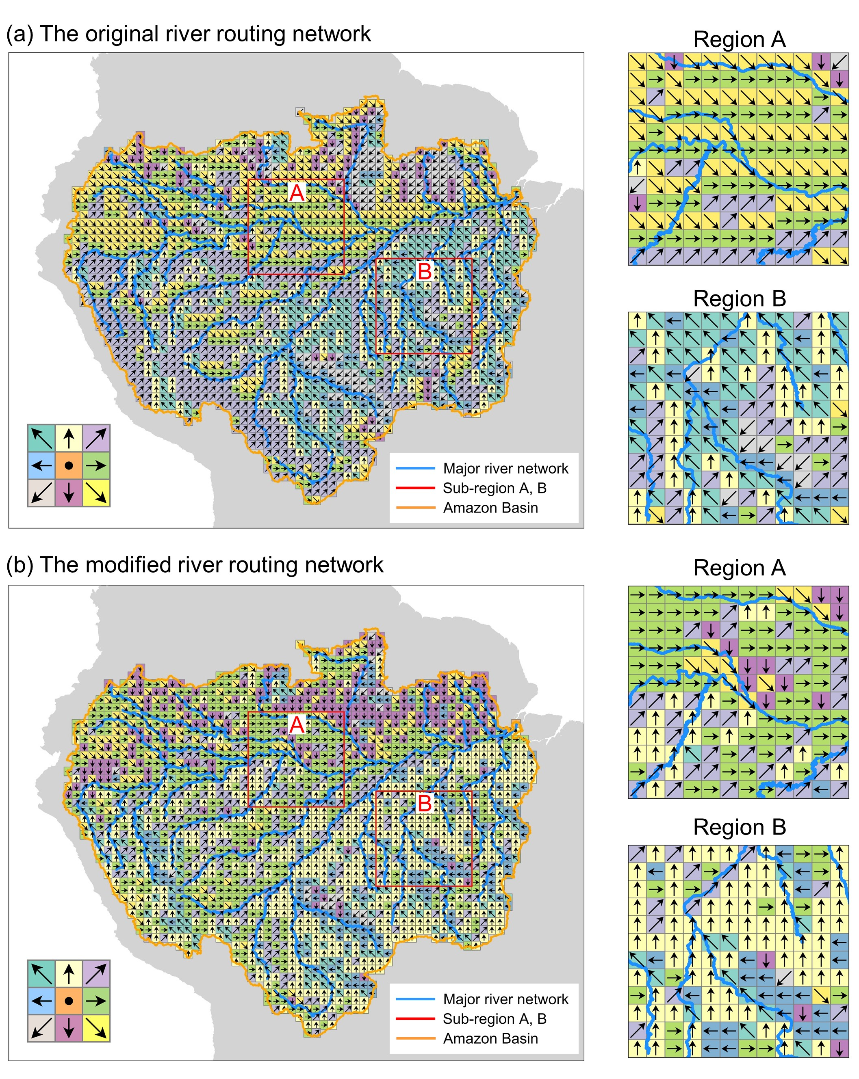
Figure S2. The river routing network (D8 flow direction) in the Amazon Basin before and after manual correction. (a) The original river routing network in HydroPy. (b) The modified river routing network using the Amazon Major River Networks from the Global Runoff Data Centre (GRDC) as a reference. The red boxes indicate the focus areas, Regions A and B. Note that only flow directions into the basin are displayed, while flow directions in the boundary grids are not shown.

Figure S3
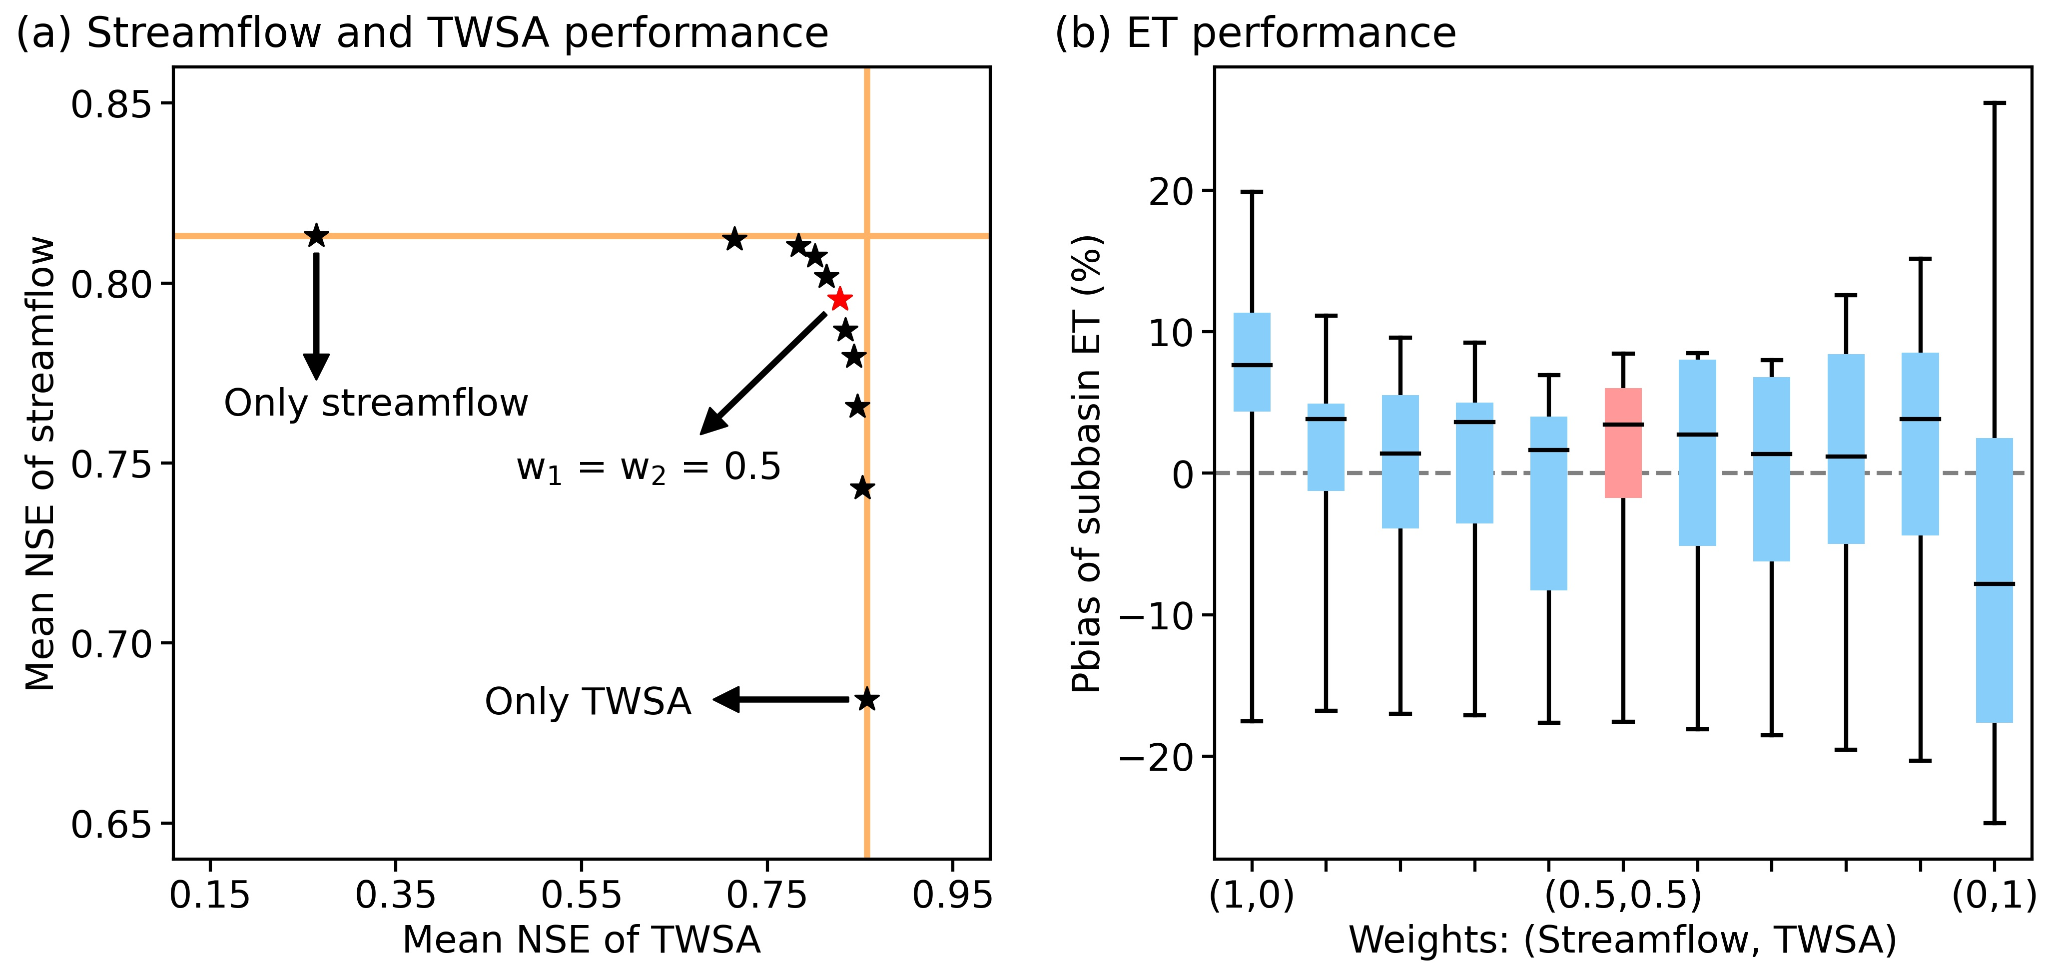
Figure S3. Performance of Hybrid(Q,S)+ with different weighting schemes in the temporal splitting experiment. (a) Performance in modeling streamflow and grid-scale TWSA during the validation period (2013-2016). The x-axis represents the average Nash-Sutcliffe efficiency (NSE) for TWSA at the 56 3°×3° grid cells, and the y-axis represents the average NSE for streamflow at the 24 hydrological stations. Each pentagram represents a weighting scheme, with the red one indicating the equal weighting scheme. There are 11 weighting schemes in total, with the leftmost pentagram being [1, 0] for streamflow and TWSA and the rightmost one being [0, 1]. (b) Performance in modeling sub-basin ET during the validation period. The x-axis represents the weighting schemes, and the y-axis represents the percentage bias (Pbias) for the annual ET of the nine sub-basins. The box plot in red indicates the equal weighting scheme.

Figure S4
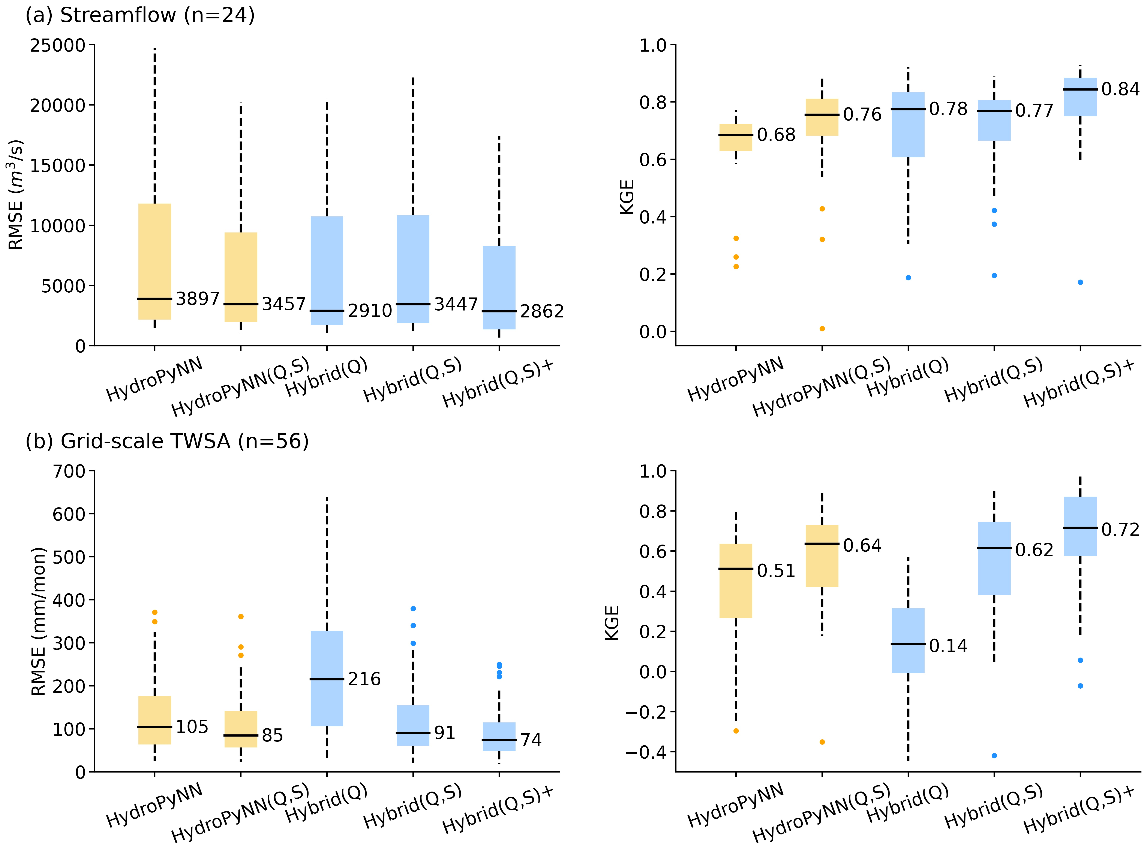
Figure S4. Performance in predicting dynamic streamflow and TWSA with different neural network-based models during the validation period. (a) Root mean square error (RMSE) and Kling–Gupta efficiency (KGE; Gupta et al., 2009) values for the 24 selected streamflow stations and (b) RMSE and KGE values for the 56 grid cells (3°×3° in size). A smaller RMSE closer to 0 and a larger KGE closer to 1 indicate better model performance. The yellow boxes represent models without the parameterization NN, and the blue boxes represent hybrid models with the parameterization NN.

Figure S5
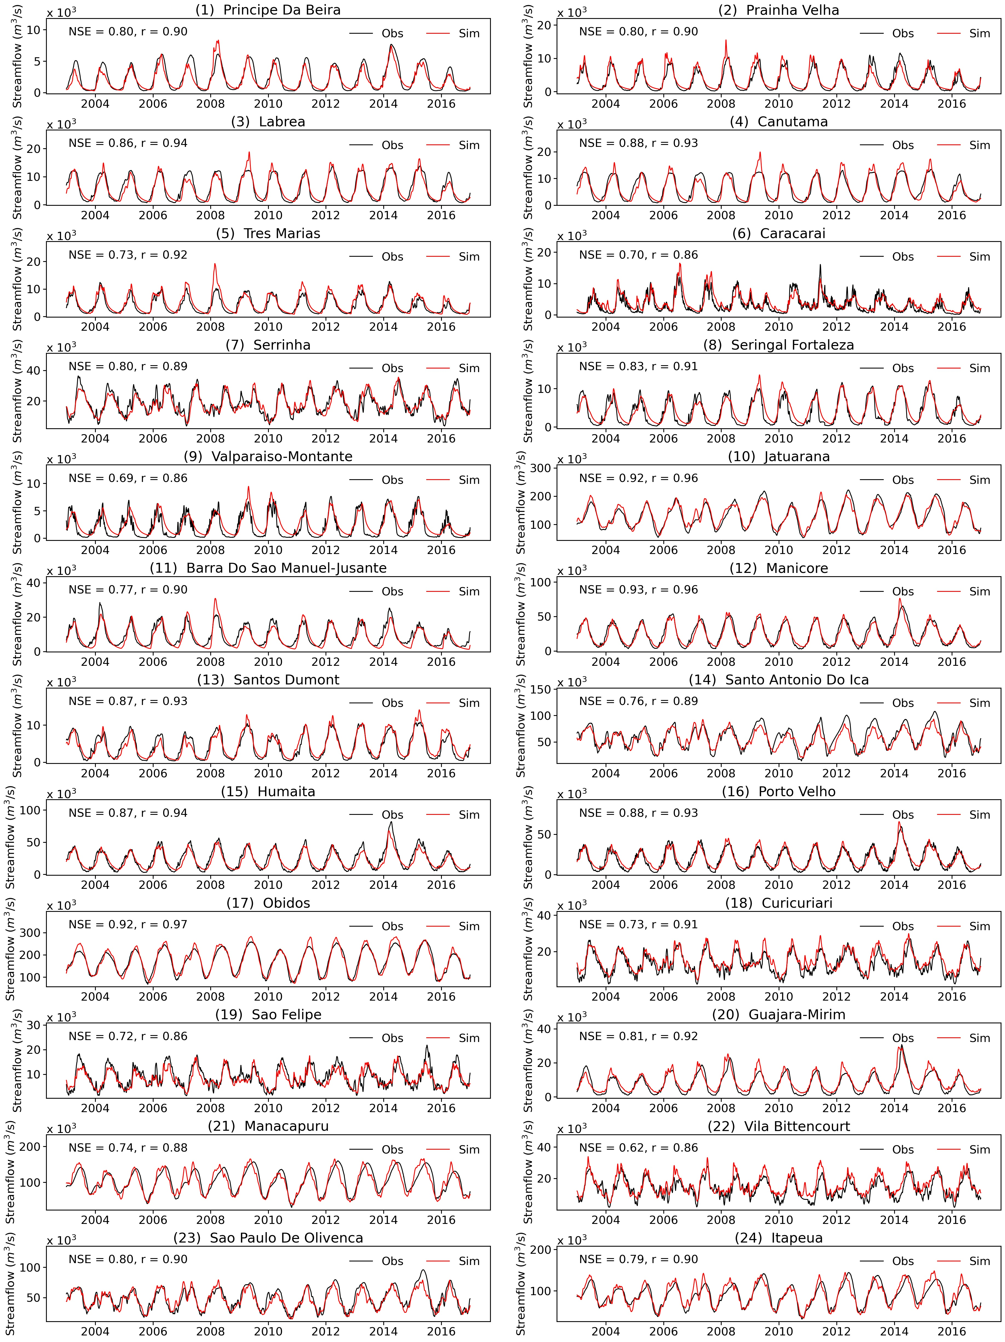
Figure S5. Time series of simulated (by Hybrid(Q,S)+) and observed streamflow at the 24 hydrological stations.

Figure S6
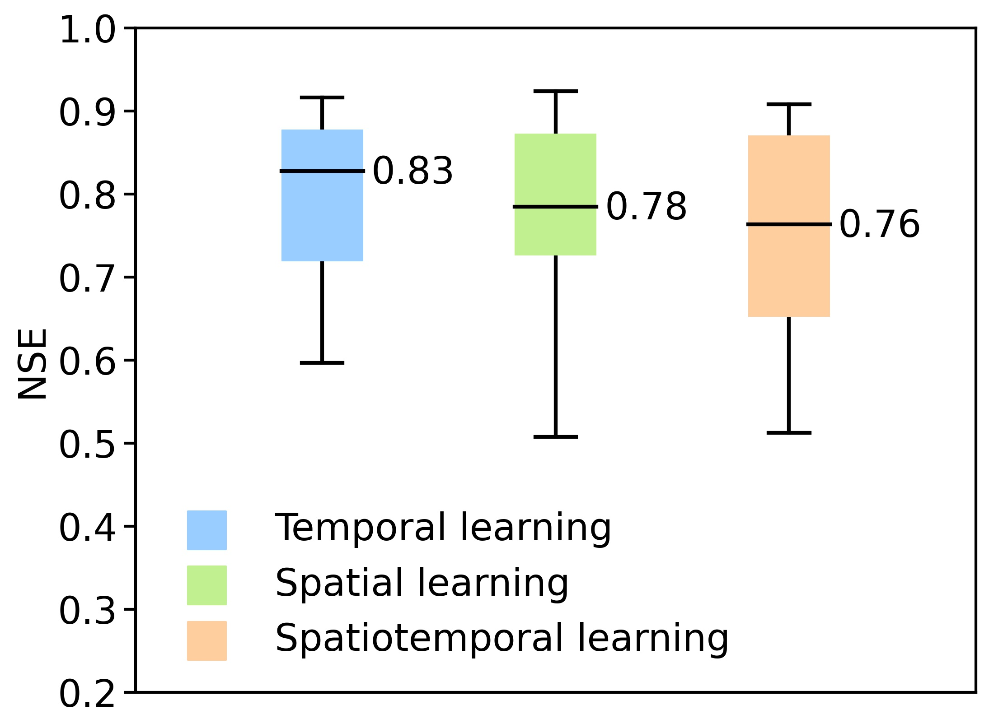
Figure S6. Performance of Hybrid(Q,S)+ under spatiotemporal splitting. The box and whisker plots present the NSE values of the streamflow simulations at the 24 validation stations via four-fold cross-validation. The blue, green, and orange boxes reflect the temporal, spatial, and spatiotemporal learning capabilities, respectively.

Figure S7
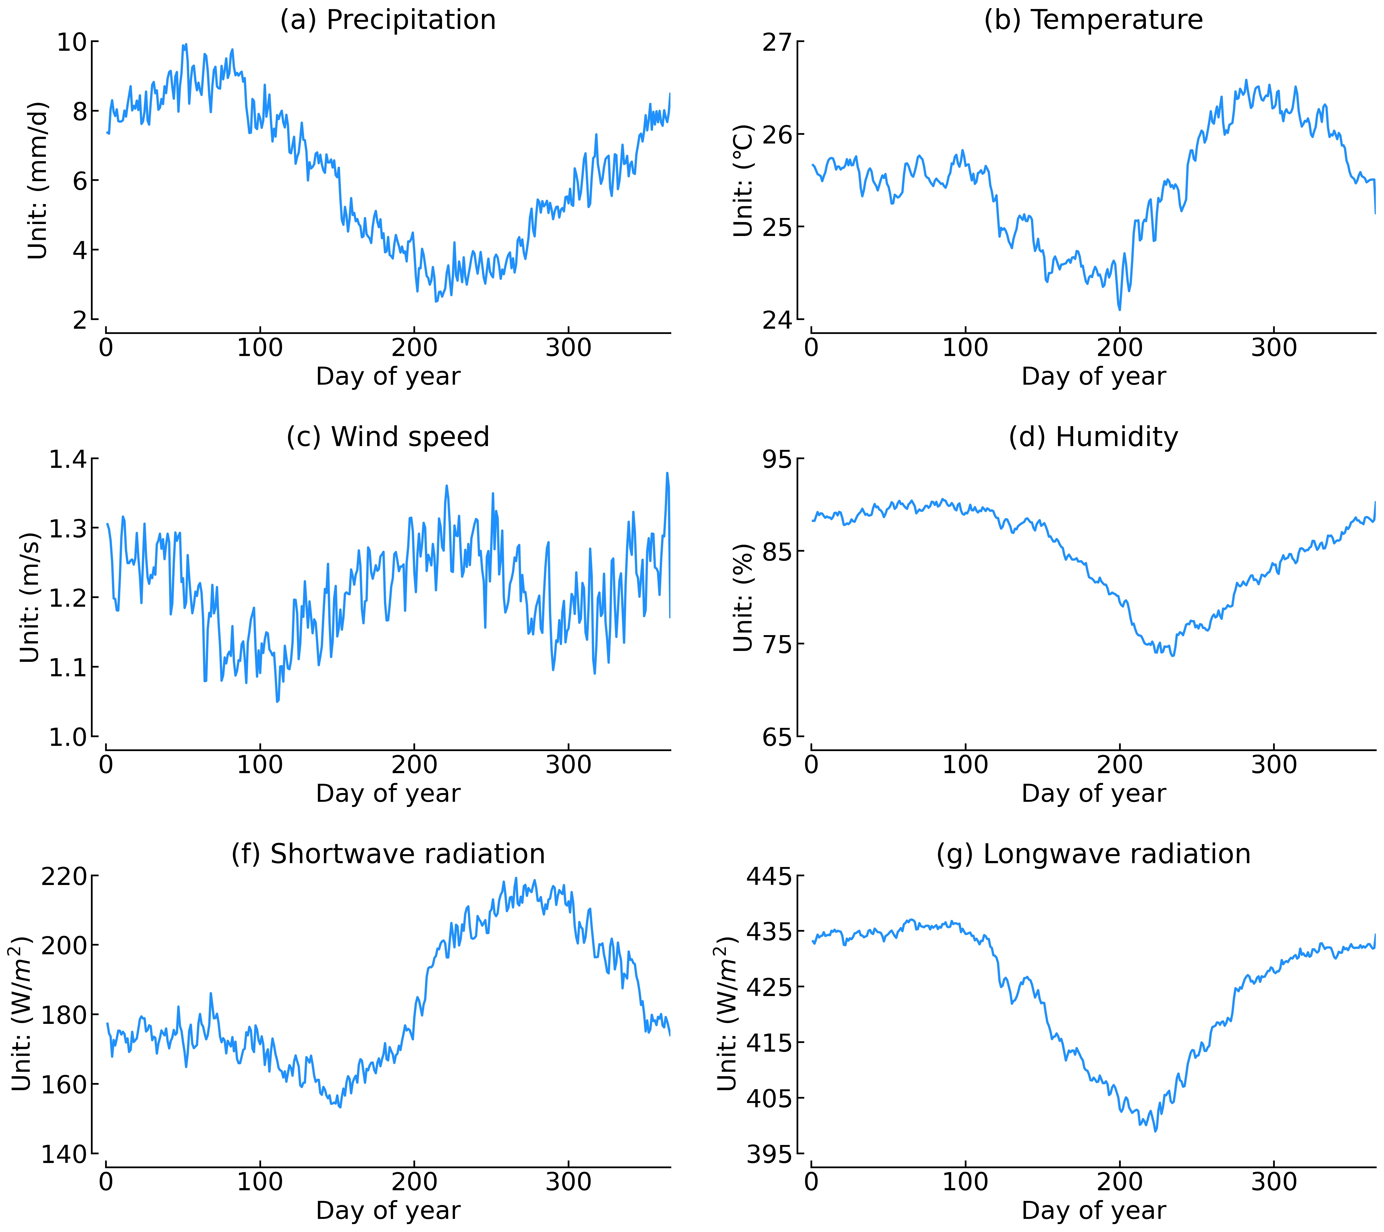
Figure S7. The daily basin-scale climatology of the main meteorological forcings from the WFDEI dataset (Weedon et al., 2014). The results above are calculated based on data from 2003 to 2016.

Figure S8
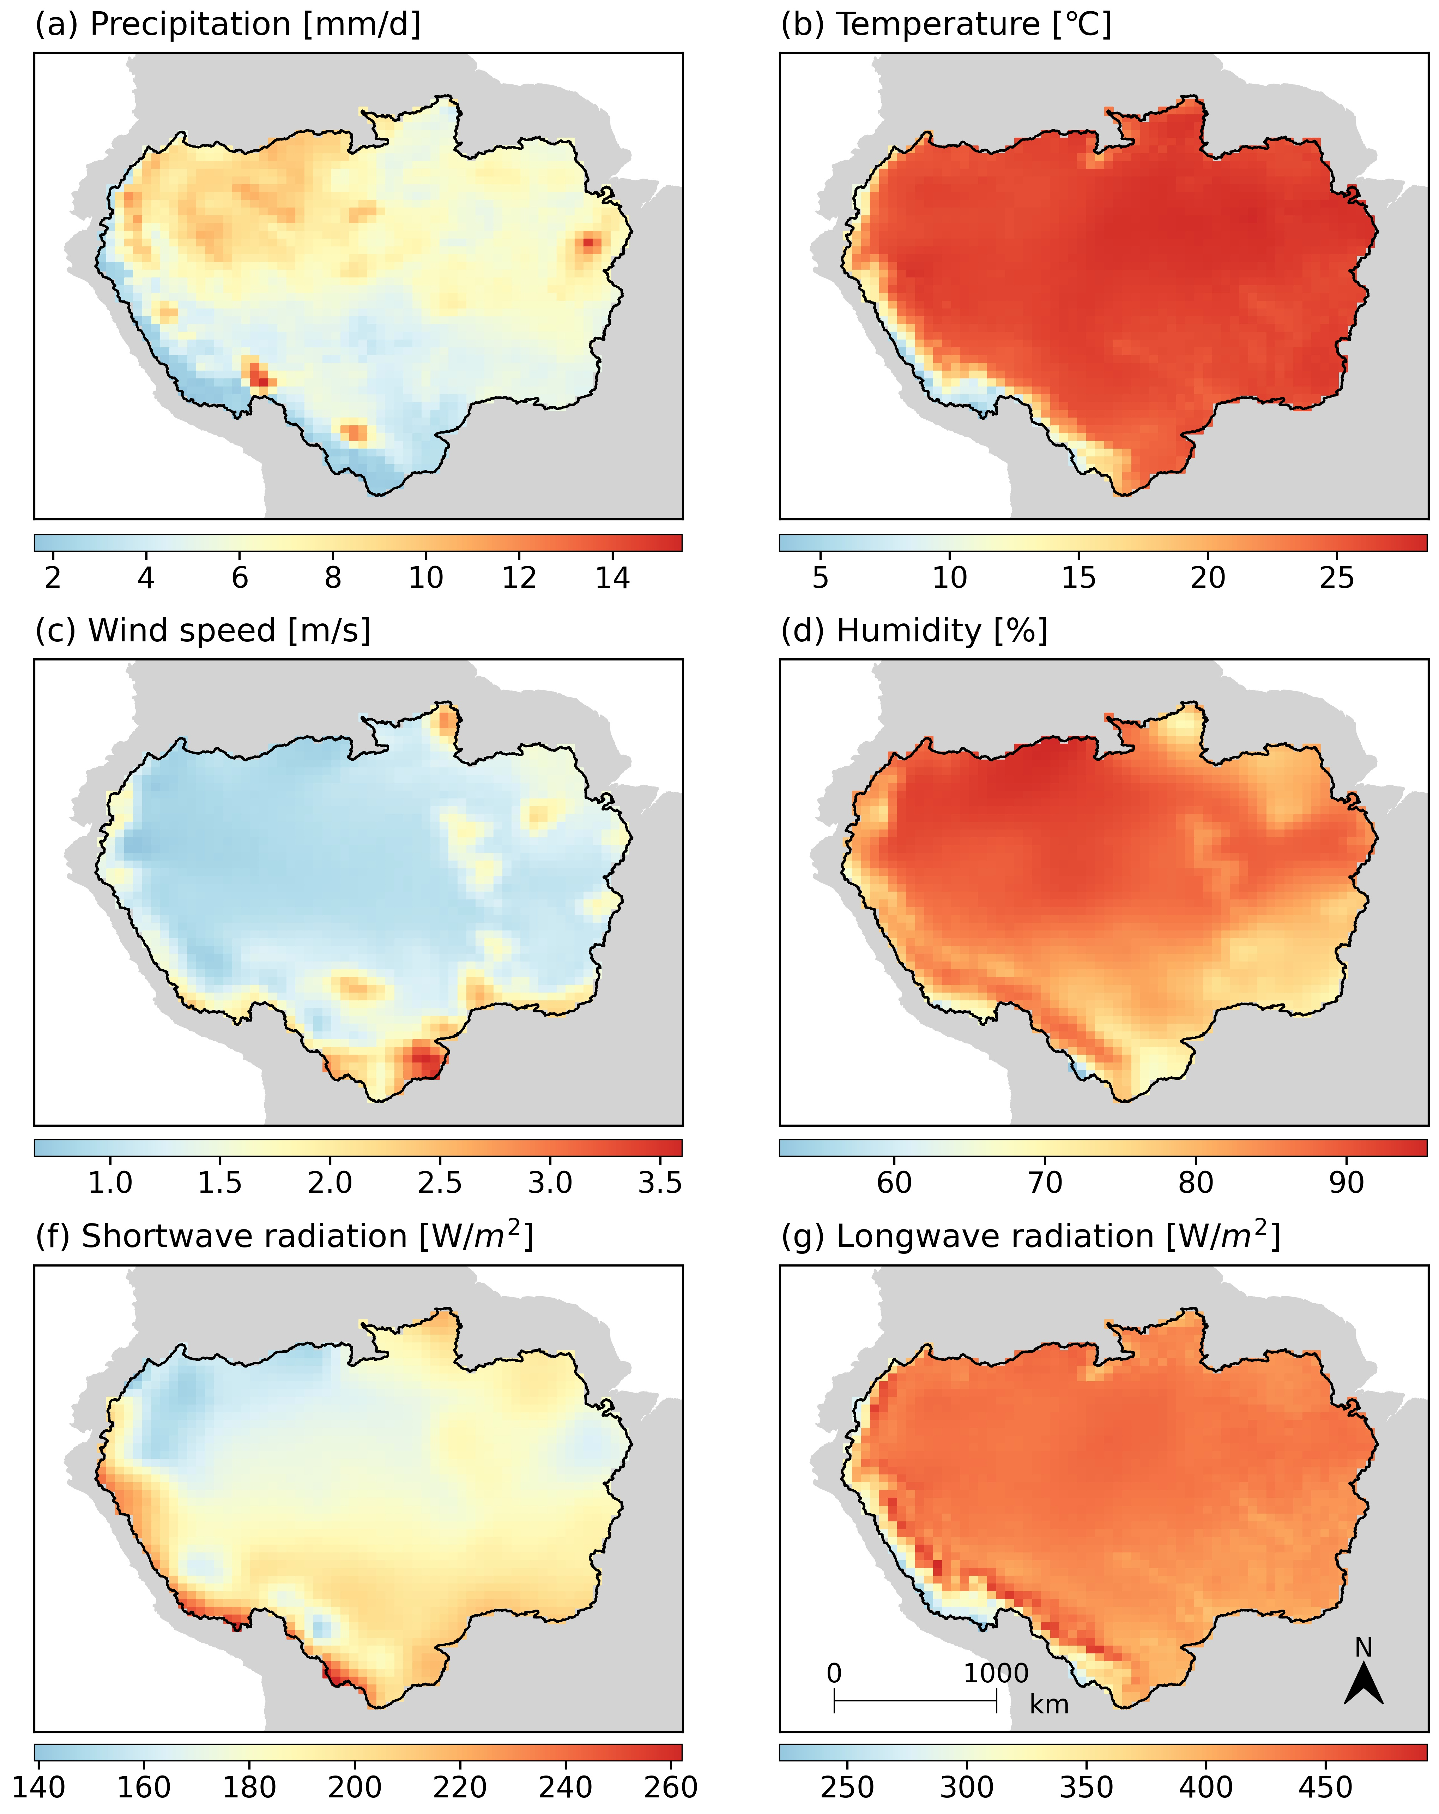
Figure S8. The spatial maps of the main meteorological forcings from the WFDEI dataset. The above results are calculated from the time-averaged daily data between 2003 and 2016.

Figure S9
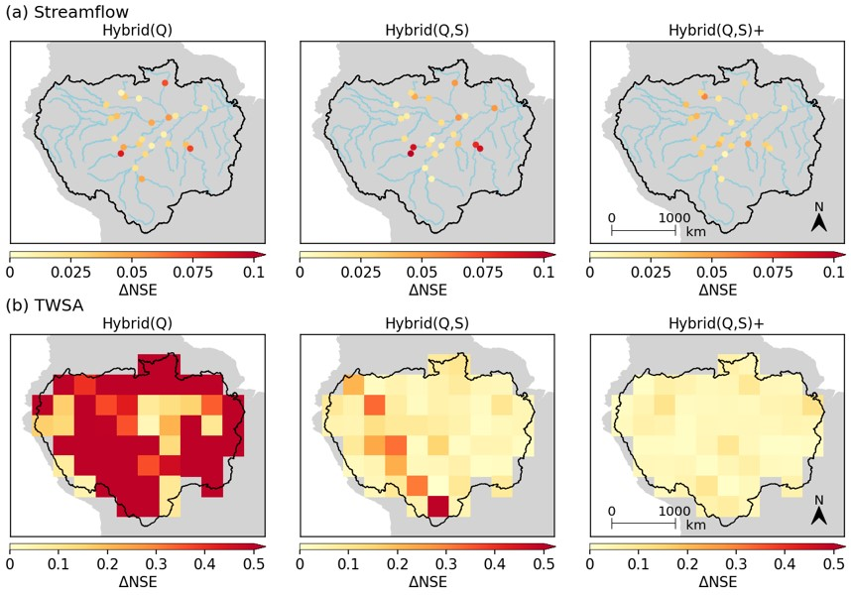
Figure S9. The change range of NSE ($∆NSE={NSE}_{max}-{NSE}_{min}$) in terms of streamflow and TWSA predictions for three DL-based hybrid models under ten random repeat runs during the study period (2003-2016). (a) $∆NSE$ of streamflow at the 24 selected hydrological stations. The ranges of the station-averaged NSE for Hybrid(Q), Hybrid(Q,S), and Hybrid(Q,S)+ are 0.03, 0.03, and 0.01, respectively. (b) $∆NSE$ of the TWSA on 56 grid cells with a 3×3° resolution. The ranges of the grid-averaged NSE for Hybrid(Q), Hybrid(Q,S), and Hybrid(Q,S)+ are 1.11, 0.06, and 0.02, respectively. Hybrid(Q) used only streamflow for training, resulting in a wide range of NSEs for TWSA prediction.

Figure S10
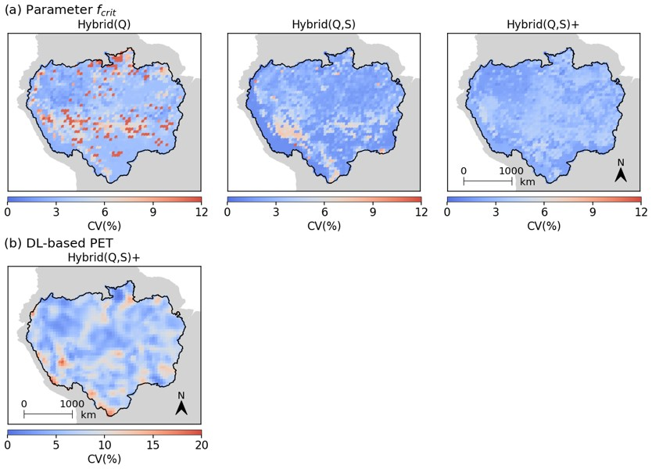
Figure S10. The coefficient of variation (CV; CV= standard deviation/mean value) in terms of $f_{crit}$ and long-term average PET derived from different DL-based hybrid models in ten random repeat runs. (a) CVs of $f_{crit}$ obtained for Hybrid(Q), Hybrid(Q,S), and Hybrid(Q,S)+. The 25th percentile, 50th percentile, and 75th percentile of the CV for Hybrid(Q) are 3.0%, 3.3%, and 4.6%, respectively. The 25th percentile, 50th percentile, and 75th percentile of the CV for Hybrid(Q,S) are 1.7%, 2.2%, and 3.3%, respectively. The 25th percentile, 50th percentile, and 75th percentile of the CV for Hybrid(Q,S)+ are 2.2%, 2.9%, and 3.6%, respectively. (b) The CV of the time-averaged PET derived from Hybrid(Q,S)+. The 25th percentile, 50th percentile, and 75th percentile of the CV for Hybrid(Q,S)+ are 5.0%, 6.6%, and 8.4%, respectively.

Figure S11
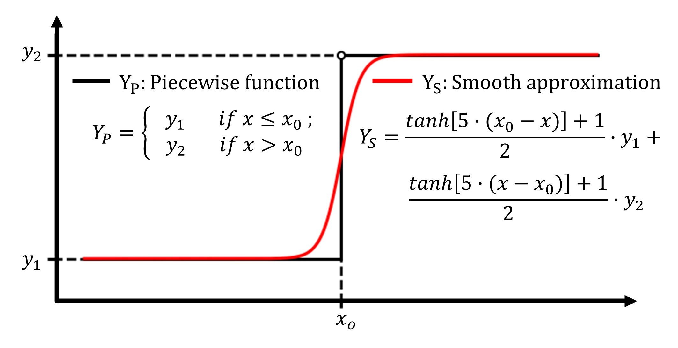
Figure S11. Schematic diagrams of the original piecewise function and the smooth approximation. The x-axis represents an input, where x0 is a threshold. The y-axis represents the response. Note that this figure illustrates a simplified case. Hydrological models can involve intricate segmentation with multiple thresholds and diverse functional forms across these thresholds. Therefore, a smooth approximation needs to be designed accordingly.

Table S1. Basic information for the 21 static attributes inputted into the parameterization NN and the replacement NN.
Attribute | Description | Source
Area | Grid cell area | Derived from Stacke & Hagemann (2021)
Topo | Surface elevation | Derived from Stacke & Hagemann (2021)
Topo_std | Standard deviation of sub-grid elevation | Derived from Stacke & Hagemann (2021)
Slope_avg | Mean sub-grid slope | Derived from Stacke & Hagemann (2021)
Wcap | Max soil water capacity | Derived from Stacke & Hagemann (2021)
Wava | Plant available water | Derived from Stacke & Hagemann (2021)
Wmin | Min sub-grid water holding capacity | Derived from Stacke & Hagemann (2021)
Wmax | Max sub-grid water holding capacity | Derived from Stacke & Hagemann (2021)
Beta | Beta parameter distribution | Derived from Stacke & Hagemann (2021)
Boro | Rescaled orographic standard deviation | Derived from Stacke & Hagemann (2021)
B | The sub-grid distribution of the soil moisture capacity | Derived from Stacke & Hagemann (2021)
LAI_avg | Mean monthly leaf area index (LAI) | Derived from Stacke & Hagemann (2021)
LAI_max | Max monthly LAI | Derived from Stacke & Hagemann (2021)
LAI_diff | Difference between max and min monthly LAI | Derived from Stacke & Hagemann (2021)
Fveg_avg | Mean monthly vegetation fraction (Fveg) | Derived from Stacke & Hagemann (2021)
Fveg_max | Max monthly Fveg | Derived from Stacke & Hagemann (2021)
Fveg_diff | Difference between max and min monthly Fveg | Derived from Stacke & Hagemann (2021)
Prcp_avg | Long-term average precipitation | Derived from the WFDEI dataset
PET_avg | Long-term average potential evapotranspiration (PET) | Derived from the WFDEI dataset
Temp_avg | Long-term average temperature | Derived from the WFDEI dataset
Aridity | Ratio of PET_avg to Prcp_avg | Derived from the WFDEI dataset
Note: PET is estimated using the Penman‒Monteith approach (Allen et al., 1998).

Table S2. The simulation performance of the hybrid model using different deep NN structures within the replacement NN.
Input scheme | Network structure | Average NSE  of streamflow |  | Average NSE  of TWSA
Input scheme | Network structure | Train | Test | Train | Test
6 dynamic forcings | FCNN | 0.71 | 0.65 | 0.75 | 0.55
6 dynamic forcings | Conv3D | 0.76 | 0.73 | 0.77 | 0.59
6 dynamic forcings and  21 static attributes | FCNN | 0.79 | 0.76 | 0.79 | 0.66
6 dynamic forcings and  21 static attributes | Conv3D | 0.83 | 0.79 | 0.84 | 0.72
Note: The best results are highlighted in red font.

Table S3. Basic information for the six meteorological input variables used in the Penman‒Monteith equation.
Variable | Description | Data source
Tmin | Min temperature during a day | Derived from the WFDEI dataset
Tmax | Max temperature during a day | Derived from the WFDEI dataset
Wind | Daily wind speed | Derived from the WFDEI dataset
Humi | Daily relative humidity | Derived from the WFDEI dataset
Srad | Daily shortwave radiation | Derived from the WFDEI dataset
Lrad | Daily longwave radiation | Derived from the WFDEI dataset
Note: The six meteorological variables are also used as the inputs of the replacement NN.

Table S4. Basic information for the 24 hydrological stations.
Station name | Latitude  (°) | Longitude  (°) | Catchment area  (km²) | Average streamflow  (m³/s)
Caracarai | 1.82 | -61.12 | 124980 | 3176
Santos Dumont | -6.44 | -68.25 | 142234 | 4254
Labrea | -7.26 | -64.80 | 226351 | 5649
Barra Do Sao Manuel-Jusante | -7.34 | -58.16 | 333000 | 8828
Vila Bittencourt | -1.39 | -69.43 | 197136 | 13648
Serrinha | -0.48 | -64.83 | 279945 | 18233
Porto Velho | -8.75 | -63.92 | 976000 | 18481
Manicore | -5.82 | -61.30 | 1150000 | 24146
Santo Antonio Do Ica | -3.10 | -67.94 | 1134540 | 59421
Itapeua | -4.06 | -63.03 | 1769000 | 89981
Manacapuru | -3.31 | -60.61 | 2147736 | 102927
Obidos | -1.92 | -55.51 | 4680000 | 171052
Guajara-Mirim | -10.79 | -65.35 | 609000 | 7650
Principe Da Beira | -12.43 | -64.43 | 341000 | 2285
Curicuriari | -0.20 | -66.80 | 194462 | 13180
Sao Felipe | 0.37 | -67.31 | 110862 | 8864
Sao Paulo De Olivenca | -3.45 | -68.75 | 990781 | 48491
Canutama | -6.54 | -64.38 | 230012 | 6143
Seringal Fortaleza | -7.72 | -67.00 | 153016 | 3743
Valparaiso-Montante | -8.65 | -67.38 | 103285 | 2047
Humaita | -7.50 | -63.02 | 1090000 | 23175
Prainha Velha | -7.21 | -60.65 | 131000 | 3286
Tres Marias | -7.61 | -57.95 | 138000 | 3961
Jatuarana | -3.06 | -59.65 | 2854286 | 128420

Table S5. The hyperparameters of the neural networks and the training process.
Hyperparameters of neural networks
Network name | Parameterization NN | Replacement NN
Network structure | FCNN | Conv3D
Number of layers | 5 | 5
Number of neurons | 21, 256, 64, 16, 9 | 27, 32, 16, 8, 1
Input variable | Static attributes | Static attributes &  Dynamic forcings
Input shape | [60, 72, 21] | [60, 72, 21] &  [timesteps, 60, 72, 6]
Output variable | Physical parameters | PET
Output shape | [60, 72, 9] | [timesteps, 60, 72, 1]
Hyperparameters of training process
Optimization algorithm | Adam
Learning rate | 0.0005
Epoch number | 300

Table S6. Comparison between the original HydroPy and its neural network version HydroPyNN regarding runoff, streamflow, and TWS at the grid scale. The comparison is based on the 1951 grid cells within the modeling domain over the period 2003-2016.
Variable name | Evaluation matrix | q25 | q50 (median) | q75
Runoff | Pbias (%) | -1.97% | -0.63% | 1.29%
Runoff | NSE | 0.98 | 0.99 | 1.00
Runoff | Corr | 0.99 | 1.00 | 1.00
Streamflow | Pbias (%) | -2.60% | -1.42% | 0.83%
Streamflow | NSE | 0.99 | 1.00 | 1.00
Streamflow | Corr | 1.00 | 1.00 | 1.00
Total water storage | Pbias (%) | -1.59% | -0.49% | 1.92%
Total water storage | NSE | 0.88 | 0.95 | 0.97
Total water storage | Corr | 0.98 | 0.99 | 0.99
Note: Pbias, NSE and Corr stand for percentage bias, Nash-Sutcliffe efficiency and correlation coefficient, respectively. q25, q50, and q75 represent the 25th, 50th (i.e., median), and 75th percentiles, respectively.

Table S7. Basic information for the nine Amazon sub-basins.
Sub-basin | Control station | Annual precipitation  (mm/yr) | Annual runoff  (mm/yr)
Sub 1 | Caracarai | 2289 | 768
Sub 2 | Serrinha | 3190 | 2043
Sub 3 | Vila Bittencourt | 3232 | 1973
Sub 4 | Santo Antonio Do Ica | 2354 | 1597
Sub 5 | Santos Dumont | 2159 | 891
Sub 6 | Canutama | 1919 | 791
Sub 7 | Manicore | 1707 | 642
Sub 8 | Prainha Velha | 2019 | 839
Sub 9 | Barra Do Sao Manuel-Jusante | 1950 | 826

References
Allen, R. G., Pereira, L. S., Raes, D., & Smith, M. (1998). Crop evapotranspiration - Guidelines for computing crop water requirements - FAO Irrigation and drainage paper 56.
Gebremedhin, M. A., Lubczynski, M. W., Maathuis, B. H. P., & Teka, D. (2022). Deriving potential evapotranspiration from satellite-based reference evapotranspiration, Upper Tekeze Basin, Northern Ethiopia. Journal of Hydrology: Regional Studies, 41. https://doi.org/10.1016/j.ejrh.2022.101059
Gupta, H. V., Kling, H., Yilmaz, K. K., & Martinez, G. F. (2009). Decomposition of the mean squared error and NSE performance criteria: Implications for improving hydrological modelling. Journal of Hydrology, 377(1-2), 80-91. https://doi.org/10.1016/j.jhydrol.2009.08.003
Hagemann, S., & Dümenil, L. (1997). A parametrization of the lateral waterflow for the global scale. Climate Dynamics, 14(1), 17-31. https://doi.org/10.1007/s003820050205
Han, L., Chen, M., Chen, K., Chen, H., Zhang, Y., Lu, B., et al. (2021). A Deep Learning Method for Bias Correction of ECMWF 24–240 h Forecasts. Advances in Atmospheric Sciences, 38(9), 1444-1459. https://doi.org/10.1007/s00376-021-0215-y
Iliev, A., Kyurkchiev, N., & Markov, S. (2017). On the approximation of the step function by some sigmoid functions. Mathematics and Computers in Simulation, 133, 223-234. https://doi.org/10.1016/j.matcom.2015.11.005
Jiang, S., Zheng, Y., & Solomatine, D. (2020). Improving AI System Awareness of Geoscience Knowledge: Symbiotic Integration of Physical Approaches and Deep Learning. Geophysical Research Letters, 47(13). https://doi.org/10.1029/2020gl088229
Stacke, T., & Hagemann, S. (2021). HydroPy (v1.0): a new global hydrology model written in Python. Geoscientific Model Development, 14(12), 7795-7816. https://doi.org/10.5194/gmd-14-7795-2021
Weedon, G. P., Balsamo, G., Bellouin, N., Gomes, S., Best, M. J., & Viterbo, P. (2014). The WFDEI meteorological forcing data set: WATCH Forcing Data methodology applied to ERA-Interim reanalysis data. Water Resources Research, 50(9), 7505-7514. https://doi.org/10.1002/2014wr015638
Xia, J., Liu, Q., & Tan, L. (2023). A Deep Learning Method Integrating Multisource Data for ECMWF Forecasting Products Correction. IEEE Geoscience and Remote Sensing Letters, 20, 1-5. https://doi.org/10.1109/lgrs.2023.3307717
Zuluaga, C. F., Avila-Diaz, A., Justino, F. B., & Wilson, A. B. (2021). Climatology and trends of downward shortwave radiation over Brazil. Atmospheric Research, 250. https://doi.org/10.1016/j.atmosres.2020.105347

